Process Scheduling Queues

The process scheduling is the activity of the process manager that handles the removal of the running process from the CPU and the selection of another process on the basis of a particular strategy.
Process scheduling is an essential part of a Multiprogramming operating systems. Such operating systems allow more than one process to be loaded into the executable memory at a time and the loaded process shares the CPU using time multiplexing.

The OS maintains all PCBs in Process Scheduling Queues. The OS maintains a separate queue for each of the process states and PCBs of all processes in the same execution state are placed in the same queue. When the state of a process is changed, its PCB is unlinked from its current queue and moved to its new state queue.

The Operating System maintains the following important process scheduling queues –
- Job queue − This queue keeps all the processes in the system.
- Ready queue − This queue keeps a set of all processes residing in main memory, ready and waiting to execute. A new process is always put in this queue.
- Device queues − The processes which are blocked due to unavailability of an I/O device constitute this queue.
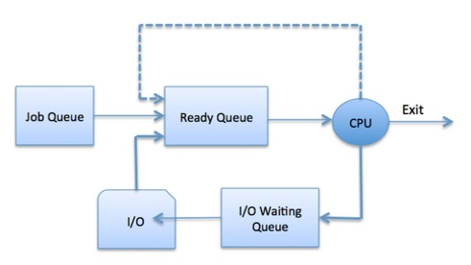
Figure – Process Scheduling

The OS can use different policies to manage each queue (FIFO, Round Robin, Priority, etc.). The OS scheduler determines how to move processes between the ready and run queues which can only have one entry per processor core on the system; in the above diagram, it has been merged with the CPU.

Two-State Process Model
Two-state process model refers to running and non-running states which are described below

State & Description:
Running: When a new process is created, it enters into the system as in the running state
Not Running: Processes that are not running are kept in queue, waiting for their turn to execute. Each entry in the queue is a pointer to a particular process. Queue is implemented by using linked list. Use of dispatcher is as follows. When a process is interrupted, that process is transferred in the waiting queue. If the process has completed or aborted, the process is discarded. In either case, the dispatcher then selects a process from the queue to execute.
A thread is a basic unit of CPU utilization, consisting of a program counter, a stack, and a set of registers, (and a thread ID.)
Traditional (heavyweight) processes have a single thread of control - There is one program counter, and one sequence of instructions that can be carried out at any given time.
As shown in Figure 4.1, multi-threaded applications have multiple threads within a single process, each having their own program counter, stack and set of registers, but sharing common code, data, and certain structures such as open files.

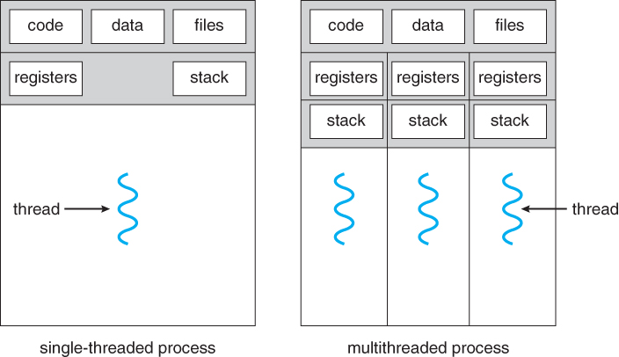

Figure – Single and Multi Threaded Processes
Advantages of Thread
- Threads minimize the context switching time.
- Use of threads provides concurrency within a process.
- Efficient communication.
- It is more economical to create and context switch threads.
- Threads allow utilization of multiprocessor architectures to a greater scale and efficiency.

Types of Thread
Threads are implemented in following two ways −
- User Level Threads − User managed threads.
- Kernel Level Threads − Operating System managed threads acting on kernel, an operating system core.

User Level Threads
In this case, the thread management kernel is not aware of the existence of threads. The thread library contains code for creating and destroying threads, for passing message and data between threads, for scheduling thread execution and for saving and restoring thread contexts. The application starts with a single thread.

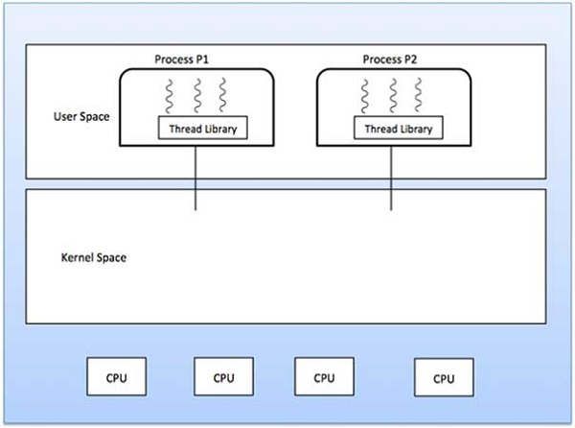

Figure – User Level Threads

Kernel Level Threads
The Thread management is done by the Kernel. There is no thread management code in the application area. Kernel threads are supported directly by the operating system. Any application can be programmed to be multithreaded. All of the threads within an application are supported within a single process.
The Kernel maintains context information for the process as a whole and for individuals threads within the process. Scheduling by the Kernel is done on a thread basis. The Kernel performs thread creation, scheduling and management in Kernel space. Kernel threads are generally slower to create and manage than the user threads.

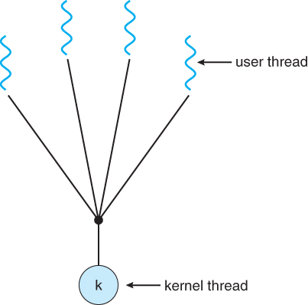

Figure – Kernel Level Threads

Multithreading Models
There are two types of threads to be managed in a modern system: User threads and kernel threads.
User threads are supported above the kernel, without kernel support. These are the threads that application programmers would put into their programs.
In a specific implementation, the user threads must be mapped to kernel threads, using one of the following strategies.
- Many-To-One Model
- One-To-One Model
- Many-To-Many Model

Many-To-One Model:
- In the many-to-one model, many user-level threads are all mapped onto a single kernel thread.
- Thread management is handled by the thread library in user space, which is very efficient.

Figure – Many-To-One Model

One-To-One Model:
- The one-to-one model creates a separate kernel thread to handle each user thread.
- One-to-one model overcomes the problems listed above involving blocking system calls and the splitting of processes across multiple CPUs.
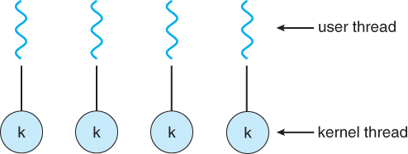

Figure – One-To-One Model

Many-To-Many Model:
- The many-to-many model multiplexes any number of user threads onto an equal or smaller number of kernel threads, combining the best features of the one-to-one and many-to-one models.
- Users have no restrictions on the number of threads created.
- Blocking kernel system calls do not block the entire process.

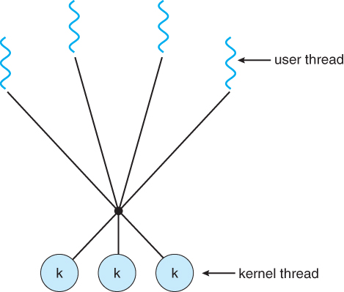

Figure – Many-To-Many Model

Schedulers:
Schedulers are special system software which handle process scheduling in various ways. Their main task is to select the jobs to be submitted into the system and to decide which process to run. Schedulers are of three types −
- Long-Term Scheduler
- Short-Term Scheduler
- Medium-Term Scheduler

Long-Term Scheduler:
It is also called a job scheduler. A long-term scheduler determines which programs are admitted to the system for processing. It selects processes from the queue and loads them into memory for execution. Process loads into the memory for CPU scheduling.

The primary objective of the job scheduler is to provide a balanced mix of jobs, such as I/O bound and processor bound. It also controls the degree of multiprogramming. If the degree of multiprogramming is stable, then the average rate of process creation must be equal to the average departure rate of processes leaving the system.

On some systems, the long-term scheduler may not be available or minimal. Time-sharing operating systems have no long term scheduler. When a process changes the state from new to ready, then there is use of long-term scheduler.

Short Term Scheduler:
It is also called as CPU scheduler. Its main objective is to increase system performance in accordance with the chosen set of criteria. It is the change of ready state to running state of the process. CPU scheduler selects a process among the processes that are ready to execute and allocates CPU to one of them.

Short-term schedulers, also known as dispatchers, make the decision of which process to execute next. Short-term schedulers are faster than long-term schedulers.

Medium Term Scheduler:
Medium-term scheduling is a part of swapping. It removes the processes from the memory. It reduces the degree of multiprogramming. The medium-term scheduler is in-charge of handling the swapped out-processes.

A running process may become suspended if it makes an I/O request. A suspended processes cannot make any progress towards completion. In this condition, to remove the process from memory and make space for other processes, the suspended process is moved to the secondary storage. This process is called swapping, and the process is said to be swapped out or rolled out. Swapping may be necessary to improve the process mi

Text Books:

1.Abraham Silberschatz, Peter B. Galvin, Greg Gagne, ―Operating System Principles‖, Wiley Student Edition, 8th Edition, 2010.
2.William Stallings, ―Operating System- Internals and Design Principles‖, Pearson Education, 6th Edition, 2002.

Reference Books:

1. Andrew S Tanenbaum, ―Modern Operating Systems‖, PHI, 3rd Edition, 2007.
2. D. M. Dhamdhere, ―Operating Systems a Concept based Approach‖, Tata McGraw-Hill, 2nd Edition, 2006.

